**Database Management System – cs422 DE**

**Lab 1 – Wk 3 & 4**

-----------------------------------------------------------------------------------------------------------------

**This Lab is based on lecture 3 & 4 (chapters 6 & 7).**

* Submit your *own work* on time. No credit will be given if the lab is submitted after the due date.
* Note that the completed lab should be submitted in .zip or .rar format only.
* If you think that your answer needs explanation to get credit then please write it down.   
  ---------------------------------------------------------------------------------------------------------------

Solve the questions from 6.32 to 6.40 in the Case Study 2 on page no. 173 (5th edition).

You are required to run & test all these queries in SQL Server. Note that you’ll need to create and populate the tables first.

To get full credit for this lab, you need to submit the following:

1. Screenshots for at least 4 of the queries with output.
2. Answer SQL queries for all of the mentioned exercises.

For your quick reference, the schema and the questions are given below.

Employee (**empID**, fName, lName, address, DOB, sex, position, deptNo)

Department (**deptNo**, deptName, mgrEmpID)

Project (**projNo**, projName, deptNo)

WorksOn (**empID**, **projNo**, hoursWorked)

where

* *Employee* contains employee details and *empID*is the key.
* *Department* contains department details and *deptNo*is the key. *mgrEmpID* identifies the employee who is the manager of the department. There is only one manager for each department.
* *Project* contains details of the projects in each department and the key is *projNo*(no two departments can run the same project).
* *WorksOn* contains details of the hours worked by employees on each project, and *empID/projNo*form the key.

**Exercises**

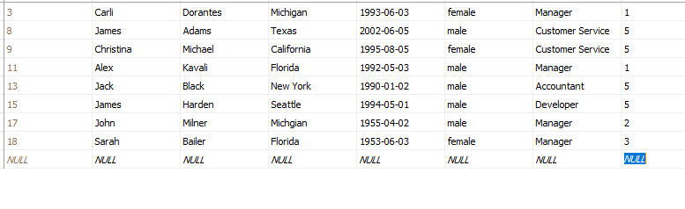

1. List all employees in alphabetical order of surname and within surname, first name.

ANS:

Select fName, lName From Employee ORDER By lName

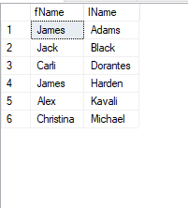

1. List all the details of employees who are female.  
   ANS:

Select * From Employee WHERE sex ='female';

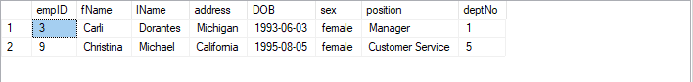

1. List the names and addresses of all employees who are Managers.

ANS:

Select fName, lName, address From Employee WHERE position ='manager'

1. Produce a list of the names and addresses of all employees who work for the IT department.

ANS:

Select fName, lName, address From Employee WHERE

deptNo = (Select deptNo From Department Where deptName ='IT')

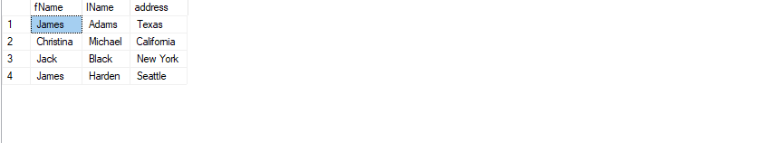

1. Produce a complete list of all managers who are due to retire this year, in alphabetical order of surname.

ANS:

Select * From Employee Where position = 'manager' And year(getdate())-year(DOB) >= 64 Order By lName

1. Find out how many employees are managed by ‘James Adams’.

ANS:

Select COUNT(*) FROM Employee Where deptNo = (Select deptNo From Employee Where fName = 'James' AND lName = 'Adams')

1. Produce a report of the total hours worked by each employee, arranged in order of department number and within department, alphabetically by employee surname.

ANS:

Select e.lName, e.fName, hoursWorked

From WorksOn w, Employee e, Department d

Where e.deptNo = d.deptNo

And e.empID = w.empID

Order By d.deptNo, e.lName

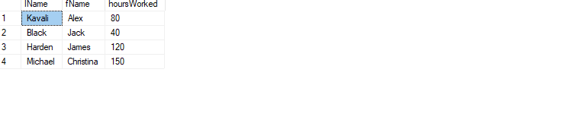

1. For each project on which more than two employees worked, list the project number, project name and the number of employees who work on that project.

ANS:

Select p.projNo, p.projName, COUNT(empID) As numberOfEmployees

From Project p, WorksOn w

Where p.projNo = w.projNo

Group By p.projNo, p.projName

Having COUNT (empID) > 2

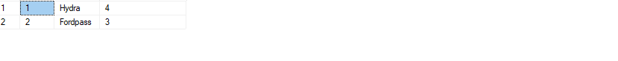

1. List the total number of employees in each department for those departments with more than 10 employees. Create an appropriate heading for the columns of the results table.

ANS:

Select COUNT(empId) as numberOfEmployees, deptNo

From Employee

Group By deptNo

Having COUNT(empId) > 10

Text Book Exercise:

6.32

List all employees from BRICS countries in alphabetical order of surname.

Select * From Staff Order By lName

6.33 List all the details of employees born between 1980–90.

Select * from Staff Where year(DOB) Between 1980 And 1990

6.34 List all managers who are female in alphabetical order of surname, and then first name

Select * From Staff

Where position = ‘Manager’ and sex=’famele’

Order By lName, fName

6.35 Remove all projects that are managed by the planning department.

Delete From Projects Where depratmentNo = ( Select departmentNo from Department Where department =’planning’)

6.36 Assume the planning department is going to be merged with the IT department. Update employee records to reflect the proposed change.

Update Employee Set departmentId = (Select departmentId from Department Where departmentName=’Planning’ )

6.37 Using the UNION command, list all projects that are managed by the IT and the HR department.

Select *

From projects

Where departmentId =

(Select departmentId from Department Where departmentName=’IT’ )

UNION

(Select departmentId from Department Where departmentName=’ HR’ )

6.38 Produce a report of the total hours worked by each female employee, arranged by department number and alphabetically by employee surname within each department.

Select SUM(hoursWorked) From Employee e, Project p, Workson Where e.empId = w.empId AND w.projNo = p.projNo And e.sex =’female’

Group By (deptNo, empID, fName, lName)

Order By deptNo, lName;

6.39 Remove all project from the database which had no employees worked..

Delete from Project Where p.projNo =( select Select p.projNo

From Project p, WorksOn w

Where p.projNo = w.projNo

Group By p.projNo

Having COUNT (empID) = 0)

6.40 List the total number of employees in each department for those departments with more than 10 employees. Create an appropriate heading for the columns of the results table.

Select COUNT(empId) as numberOfEmployees, deptNo

From Employee

Group By deptNo

Having COUNT(empId) > 10;